**YEAR 12 CHEMISTRY ATCHE**

**TEST 3 2021**

**Redox reactions, Electrochemical cells,**

**Corrosion**

**MULTIPLE CHOICE QUESTION BOOKLET**

**Part 1:** Multiple choice style consisting of TEN (10) questions.

Each question is worth 1 mark.

Write your answers on the **Multiple-choice Answer Sheet** provided.

**PART 1 – MULTIPLE CHOICE (10 MARKS)**

1. Which one of the following species listed below contains sulfur with the lowest oxidation state?

A. SO3

B. SO2

C. (NH4)2S

D. H2SO4

1. Which one of the following is not a redox reaction?
2. Mg(s) + 2 H+(aq) → Mg2+(aq) + H2(g)

B. Ag+(aq) + I–(aq) 🡪 AgI(s)

C. 2 Ag+(aq) + Zn(s) → 2 Ag(s) + Zn2+(aq)

D. Cl2(g) + 2 I–(aq) → 2 Cl–(aq) + I2(s)

1. What is the value of “x” in the equation below?

x Fe 2+ (aq) + _H + (aq) + _O2 (g) ⭢ _Fe 3+ (aq) + _H2O (l)

1. 1
2. 2
3. 4
4. 5
5. Regarding the corrosion of iron, which of the following statements is **not** correct?
6. The solid Fe loses electrons.
7. The oxidation number of O2 is decreased.
8. The precipitation of Fe(OH)2 by combination of iron(ii) ions with hydroxide is not a redox process.
9. The H2O acts as the oxidising agent.
10. Which of the following salts cannot be prepared by the reaction of a metal and a dilute acid?

A. Copper(II) sulfate

B. Iron(II) chloride

C. Nickel(II) chloride

D. Magnesium sulfate

1. Which one of the following halogen displacement reactions would **not** occur under standard conditions?
2. Br2(aq) + KCl(aq)
3. Br2(aq) + KI(aq)
4. Cl2(aq) + KBr(aq)
5. Cl2(aq) + KI(aq)

**Question 7 refers to the diagram and the equations below.**

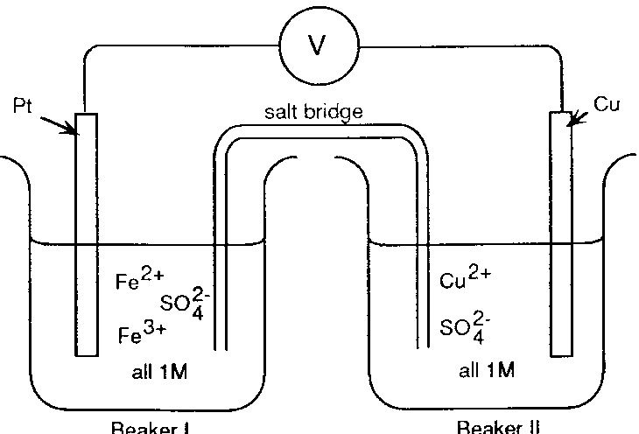

BEAKER I

BEAKER II

**Note:**

**M = molL-1**

|  |
| --- |
| Fe3+ + e‾ Fe2+ E0 = 0.77 V  Cu2+ + 2e‾ Cu E0 = 0.34 V |

1. If the salt bridge contained KNO3 solution, the:
   1. K+ ions move from beaker I and are replaced by Cu2+ ions.
   2. NO3‾ ions migrate into beaker I and are replaced by SO42‾ ions from beaker II.
   3. K+ ions move into beaker II and NO3‾ ions move into beaker I.
   4. K+ ions move into beaker I and NO3‾ ions move into beaker II.
2. In the electrolysis of a solution of copper(II) sulfate using inert electrodes, what will happen to the pH of the solution as the reaction proceeds?

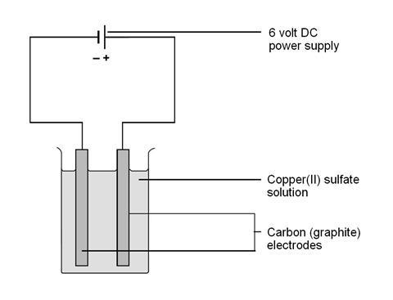

1. Increase.
2. Decrease.
3. Increase and then decrease.
4. No change
5. Which of the following factors contribute to increasing the rate of the corrosion of iron?
6. Increased air pressure
7. Increased temperature
8. Increased acidity
9. Increased humidity
10. 1 only
11. 1 and 4 only
12. 1, 2 and 4 only
13. 1, 2, 3 and 4
14. Four metals Pb, *x,* *y* and *z*, were connected in pairs and the voltage was recorded.



The results obtained are set out in the table below. List the metals from **weakest** to the **strongest** reductant.

|  |  |  |
| --- | --- | --- |
| ***Negative terminal*** | ***Positive terminal*** | ***Voltage (V)*** |
| Pb | *x* | 0.35 |
| *y* | Pb | 1.10 |
| *z* | Pb | 2.60 |

A. *z*, *y*, Pb, *x*

B. Pb, *x*, *y*, *z*

C. *x*, *y*, Pb, *z*

D. *x*, Pb, *y*, *z*

**End of Multiple-choice Questions**